Mark Pratt

CST-135

8/19/2020

Professor Elchouemi

Activity One Screenshots and Documentation

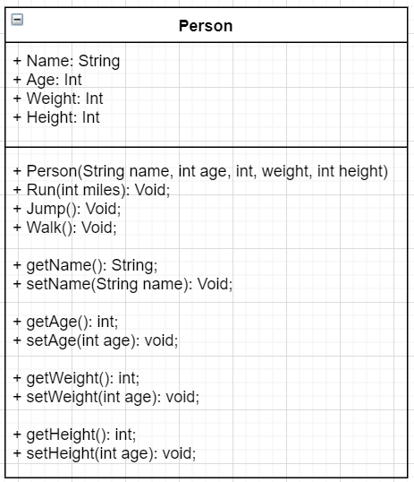

UML Diagram for the Person Class used int Activity 1 Part 2

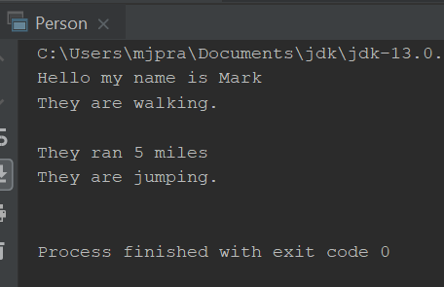

Screenshot 2, output of the Person class, activity 1 part 2

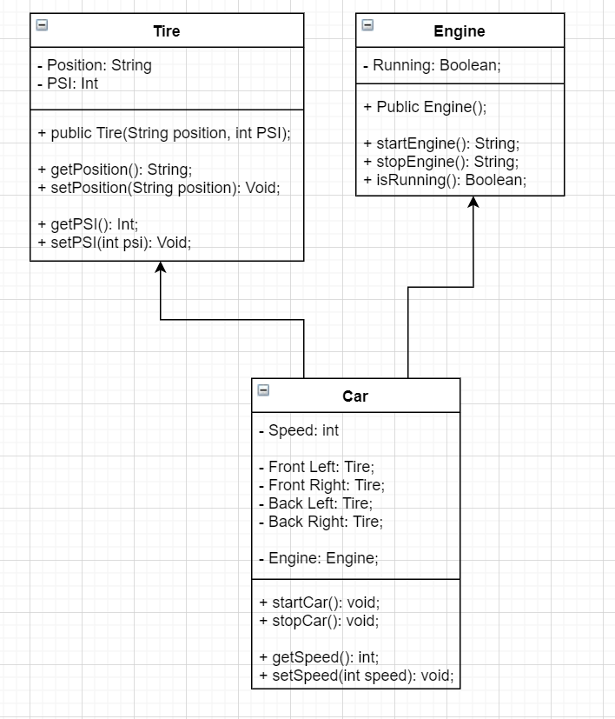

UML Diagram for Activity 1 Part 3, Car Project

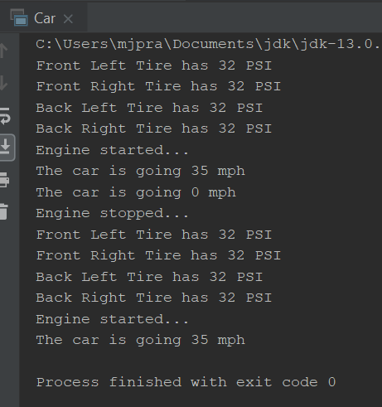

Output of car class. Car checked for proper tire pressure, then started the engine, then stopped the engine, then checked tire pressure and restarted the engine.